DMV Practice Tests: Prepare to Pass on the First Try
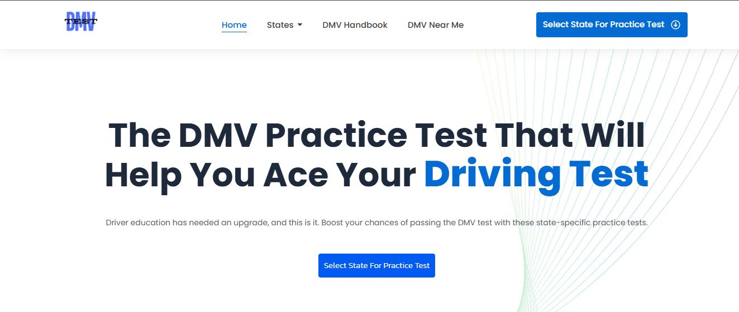
Finding your way through your driving test senses overwhelming, particularly if you're not used to road rules and driving laws. This is when DMV practice tests become invaluable. These tests simulate the best written examination, providing a clear idea of the questions you might encounter. By using practice tests, you understand topics for example traffic signs, road markings, and general driving laws. This preparation besides builds your understanding but helps as well reduce anxiety, leading you to more confident on test day. Moreover, the repetitive nature of practice questions allows you to recognize patterns and customary themes, ensuring you're well-prepared to tackle including the trickiest questions.

Among the list of key benefits of DMV practice tests is power they have to distinguish weak areas in the understanding. Often, people assume they be aware of rules of the trail, only to illinois dmv during the test that the knowledge is incomplete. Practice tests highlight these gaps, making it possible to consentrate on sections where improvement is needed. Be it understanding right-of-way laws, speed limits, or complex road scenarios, practice tests ensure that you get targeted learning opportunities. Many resources also provide detailed explanations for each and every question, aiding you understand the rationale behind correct answers and reinforcing your learning.

Another advantage of DMV practice tests is their role in time management. The written exam is often time-bound, and practice tests help you gauge how rapidly and accurately you are able to answer questions. This practice builds to be able to read and respond efficiently under time limits, an art form that's critical during the actual test. Furthermore, many online platforms offer adaptive testing, adjusting question difficulty determined by your performance. This simulates real-world testing conditions, aiding you prepare for various question formats and complexities.

In combination with knowledge and preparation, DMV practice tests also give rise to road safety. Understanding traffic laws through repeated practice ensures that new drivers are more informed and responsible on the road. As an example, concepts like merging onto highways, handling intersections, and understanding emergency vehicle protocols are necessary for safe driving. By mastering these concepts through practice tests, you're just preparing to pass an exam—you're equipping yourself with the talents required to navigate real-world driving challenges confidently and responsibly. Ultimately, DMV practice tests are more than just a report tool; they're a basis for becoming a safe and competent driver.

