How to Spot a Loose Slot Machine Online
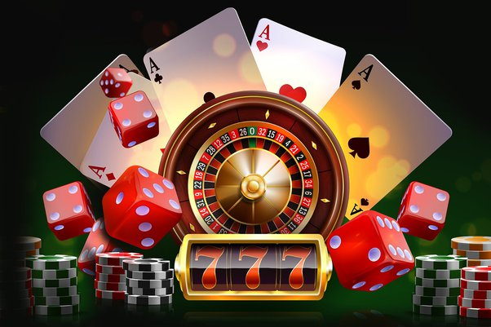
Online slots are digital versions of traditional slot machines, allowing players to enjoy casino-style gaming from the NAGAGG LOGIN of the homes. They come in various themes, designs, and formats, from classic three-reel games to more contemporary five-reel video slots. Online slots are highly accessible, with simple gameplay mechanics that need little learning, making them attractive to both beginners and experienced players. With tens of thousands of possibilities, players can choose from a wide variety of styles, bonus features, and jackpots.

Online slots use random number generators (RNGs) to determine the outcome of each spin, ensuring fairness and unpredictability. Players place a bet, spin the reels, and wait to see if the symbols align in winning combinations. Each game has its own group of paylines, and payouts are normally based on the combination of symbols displayed on the screen. The RTP (Return to Player) rate is another important factor, which indicates the percentage of wagered money a position machine is expected to pay back over time.

One of the major attractions of online slots is the range of bonus features they offer. Many online slot games include special rounds that could significantly increase a player's odds of winning, such as for instance free spins, multipliers, or progressive jackpots. Free spins allow players to spin the reels without employing their own money, while multipliers boost their winnings. Some slots also feature wilds and scatter symbols that unlock these bonuses, adding excitement and extra winning potential to the game.

Progressive jackpot slots offer players the chance to win massive prizes. Unlike regular slots, where in fact the jackpot is fixed, a progressive jackpot increases with each player's bet until someone wins the grand prize. These jackpots can reach impressive sums, sometimes worth millions, because they are linked across multiple games or casinos. This potential for huge payouts makes progressive slots a major draw for players looking for a life-changing win, though they typically have higher volatility and lower hit rates.

With the growing popularity of smartphones, mobile slots have grown to be a substantial trend in the gaming industry. Players are now able to access their favorite slot games on cellular devices, permitting on-the-go gaming anytime and anywhere. Developers have optimized these games for mobile platforms, ensuring smooth gameplay, responsive controls, and high-quality graphics. Mobile slots make the gaming experience even easier, causing the continued rise of online slots as a preferred type of entertainment.

