Exploring the Excitement of Toto Macau: A Gateway to Thrilling Entertainment
Toto Macau has emerged as one of the most popular and exciting forms of entertainment for those who enjoy the thrill of chance and the allure of winning big hptoto. As a lottery-style game, it offers players the opportunity to engage in a simple yet captivating experience, where luck and strategy intertwine to create moments of anticipation and excitement.
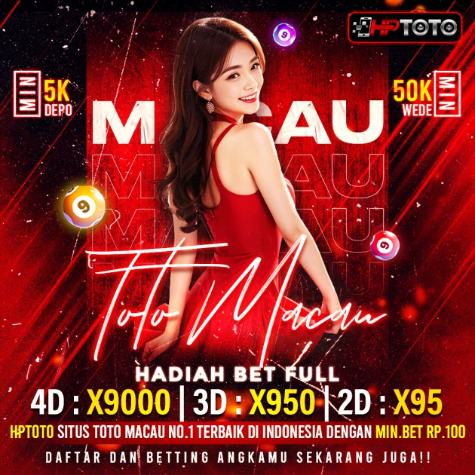
What is Toto Macau?
Toto Macau is a lottery game that has gained widespread popularity in Macau and beyond. Known for its straightforward gameplay and attractive prize structures, it attracts both seasoned players and newcomers alike. Participants select a set of numbers, and if their chosen numbers match the winning numbers drawn toto macau, they stand a chance to win substantial rewards. The simplicity of the game, combined with the potential for life-changing payouts, makes it a favorite among lottery enthusiasts.
The Appeal of Toto Macau
One of the key reasons for Toto Macau’s popularity is its accessibility. The game is easy to understand, making it appealing to a wide audience. Whether you’re a casual player looking for some fun or a dedicated participant aiming for the jackpot, Toto Macau offers something for everyone situs macau.
Additionally, the game’s frequent draws add to its excitement. With multiple opportunities to win each week, players are constantly engaged, eagerly awaiting the results of each draw. This regular cadence keeps the energy high and ensures that the thrill of the game never fades.
A Blend of Luck and Strategy
While Toto Macau is primarily a game of chance, many players enjoy incorporating strategies to enhance their experience toto macau resmi. From analyzing past results to selecting numbers based on personal significance, participants often find creative ways to approach the game. This blend of luck and strategy adds an extra layer of intrigue, making each draw a unique and engaging event.
Responsible Gaming
As with any form of gambling, it’s important to approach Toto Macau with a sense of responsibility. The game is designed to be a fun and entertaining experience, and players are encouraged to set limits and play within their means. By maintaining a balanced perspective, participants can fully enjoy the excitement of Toto Macau without compromising their well-being.
Conclusion
Toto Macau represents more than just a lottery game—it’s a gateway to thrilling entertainment and the possibility of winning big. Its simplicity, frequent draws, and potential rewards make it a standout choice for those seeking a dose of excitement in their lives. Whether you’re a first-time player or a seasoned participant, Toto Macau offers an unforgettable experience that keeps you coming back for more. So, why not try your luck and see where the numbers take you? The next draw could be your moment to shine!

